**Jenkins Task**

**Task Description:**

**Launch jenkins and explore creating projects and users.**

**Step 1: Create the EC2 Instance**

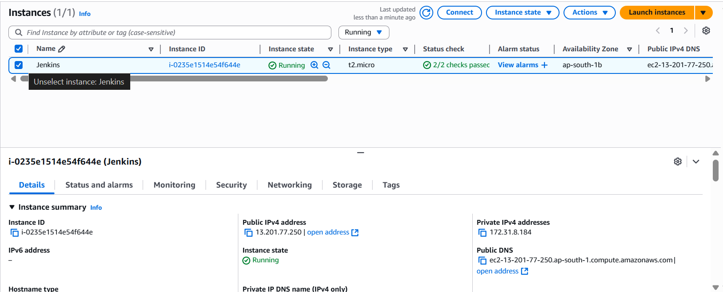

**Update the system**

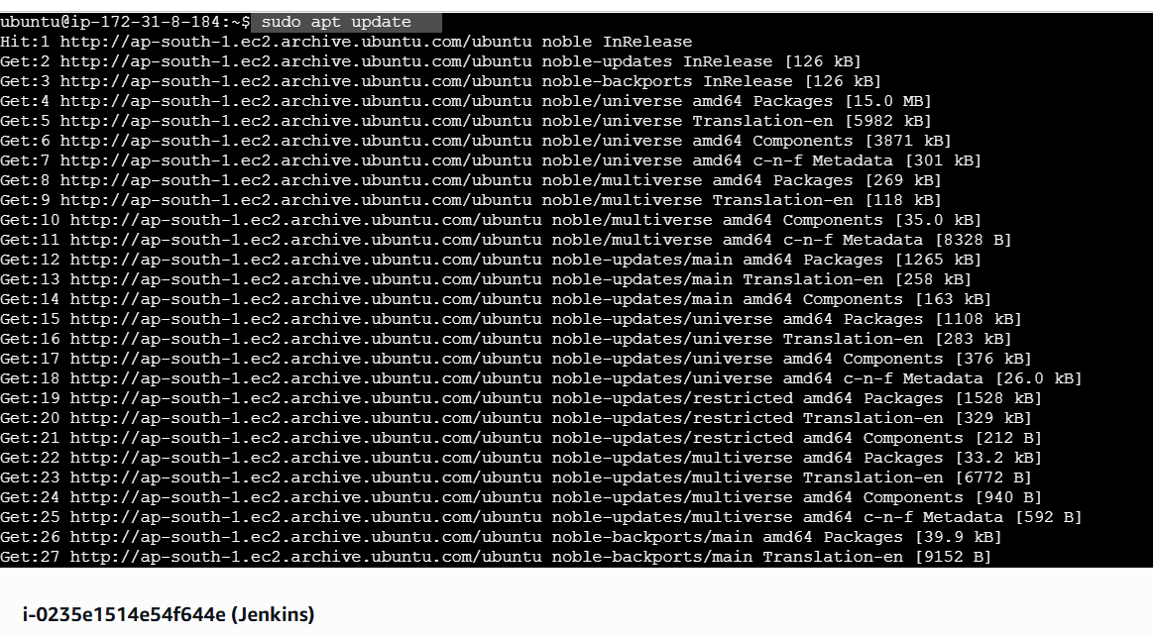**Step 2: Install Java and verify the version  
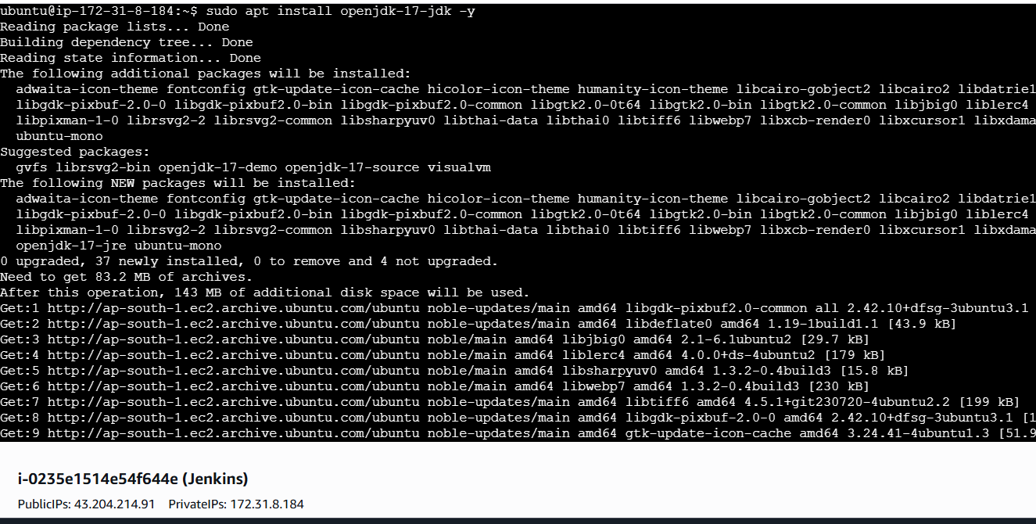**

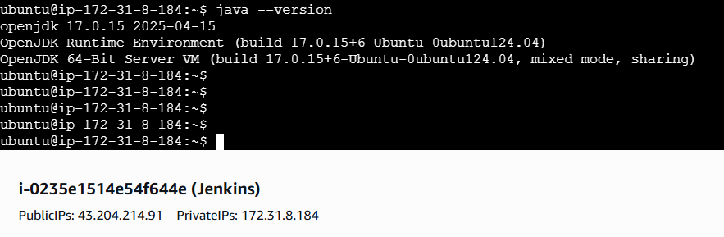**Step 3: Add Jenkins Repository & Install Jenkins ( add the repo key and add the Jenkins repo)  
  
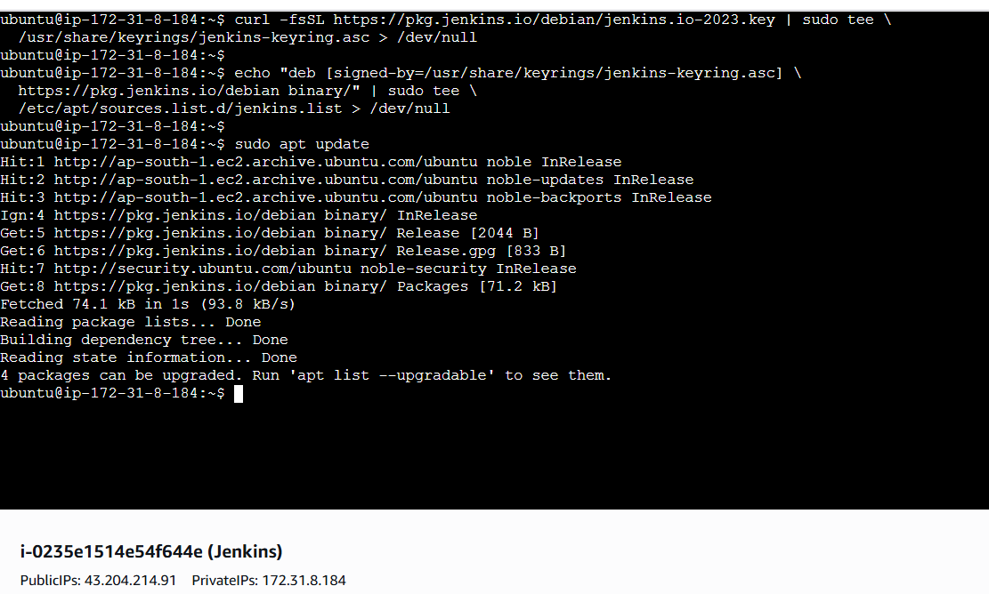**

**-> Update packages and install Jenkins:**

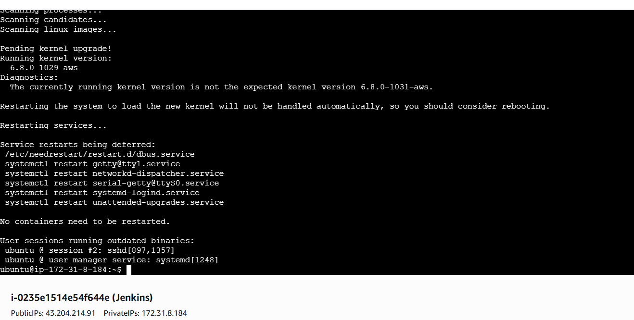

**Step 4: Start and Enable Jenkins  
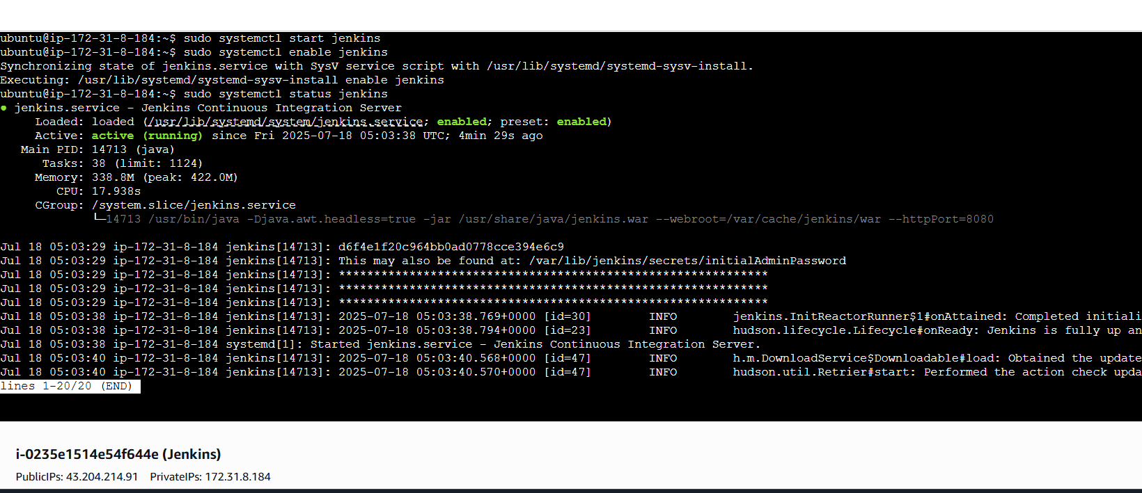**

**Step 5: Setup Jenkins**

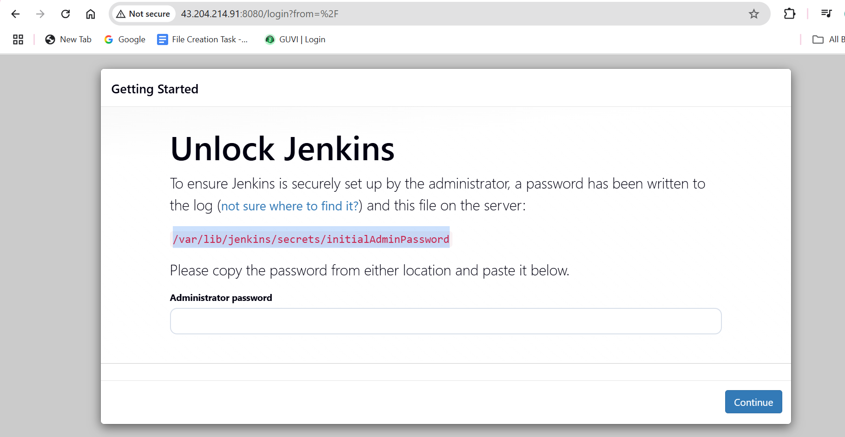

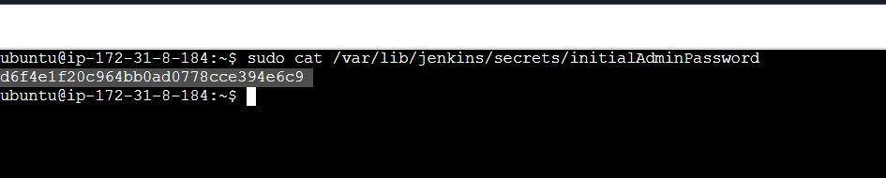

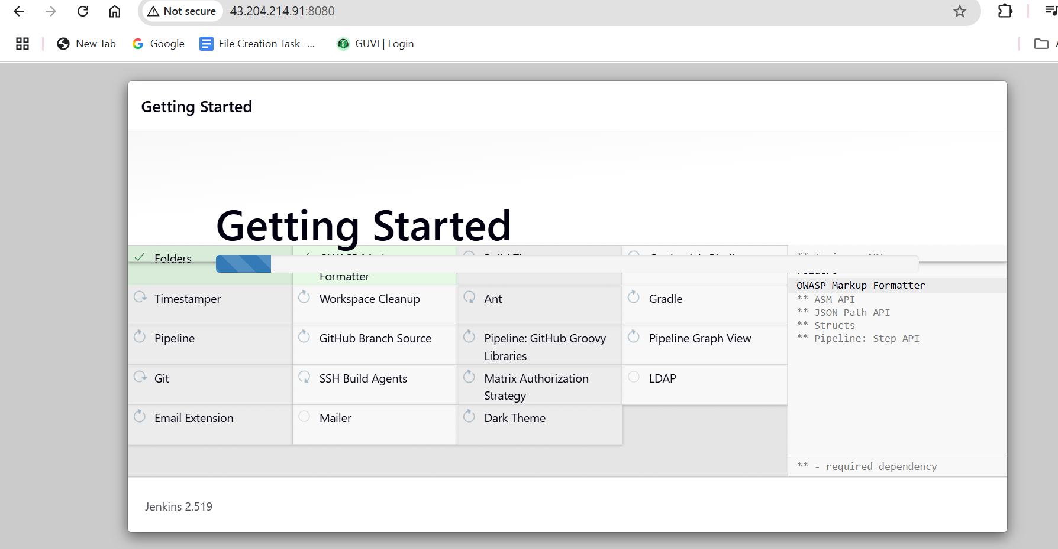

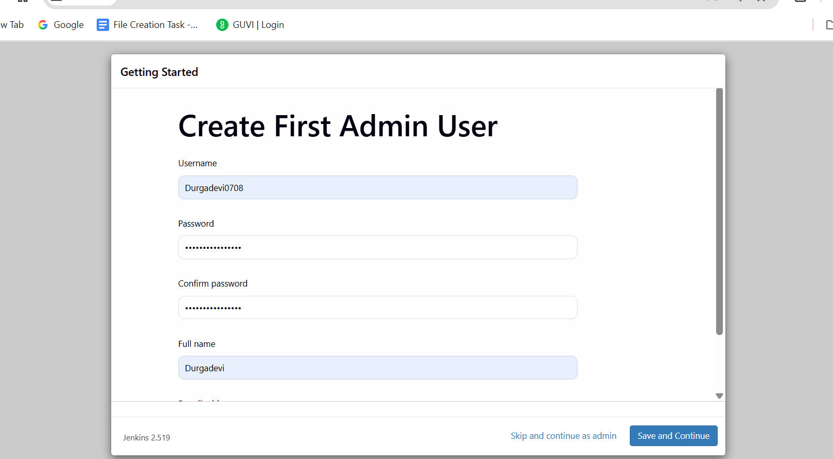

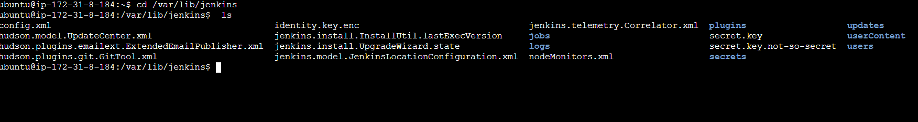

**Creating project in Jenkins (Python)  
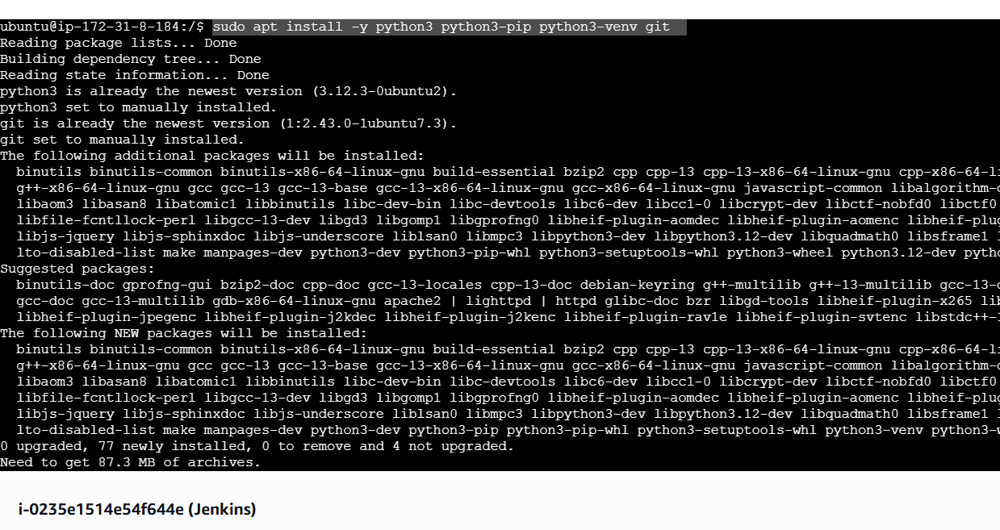**

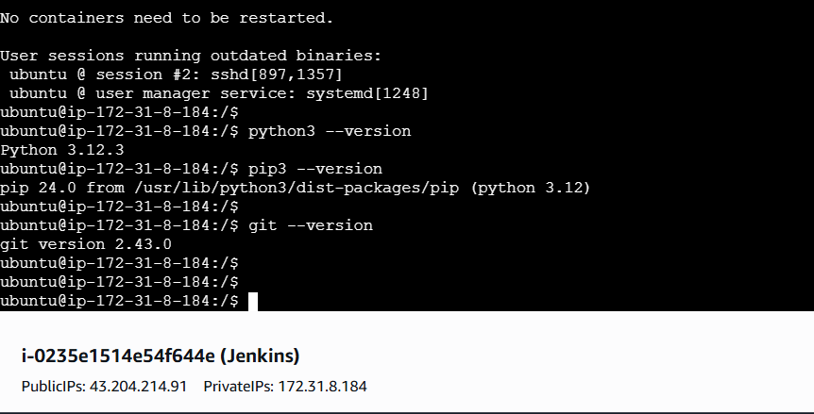

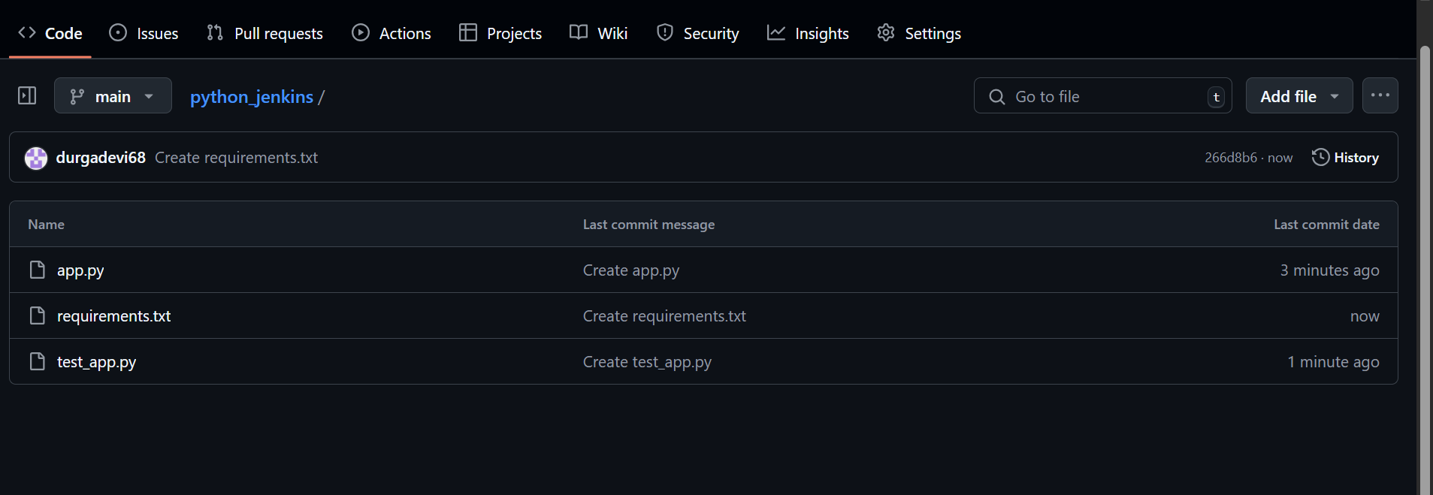

**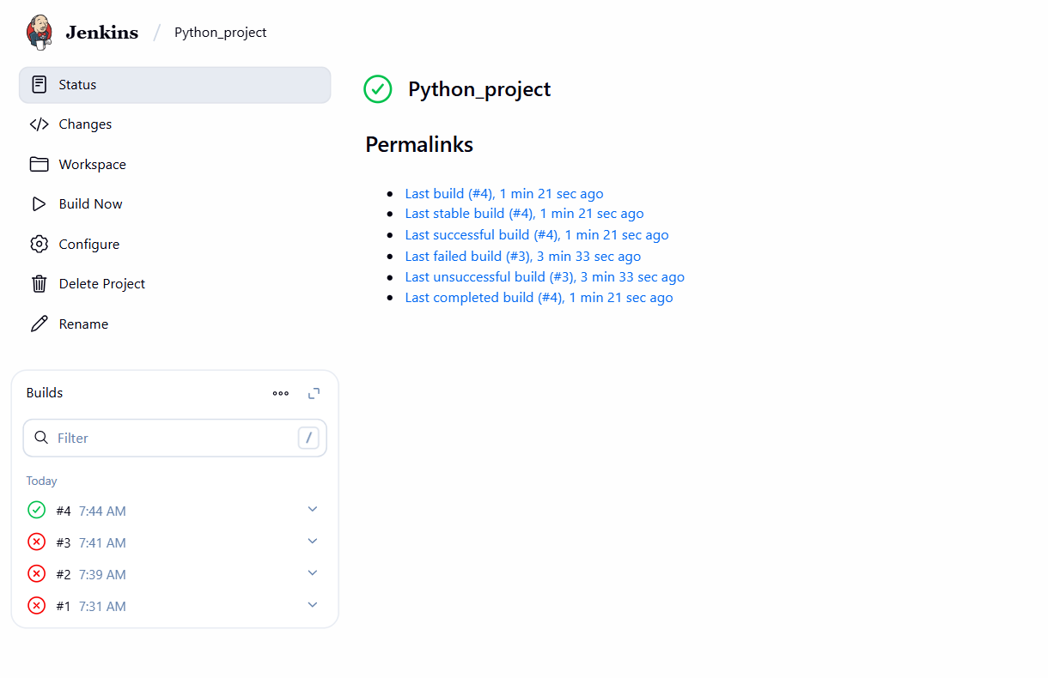  
ss  
